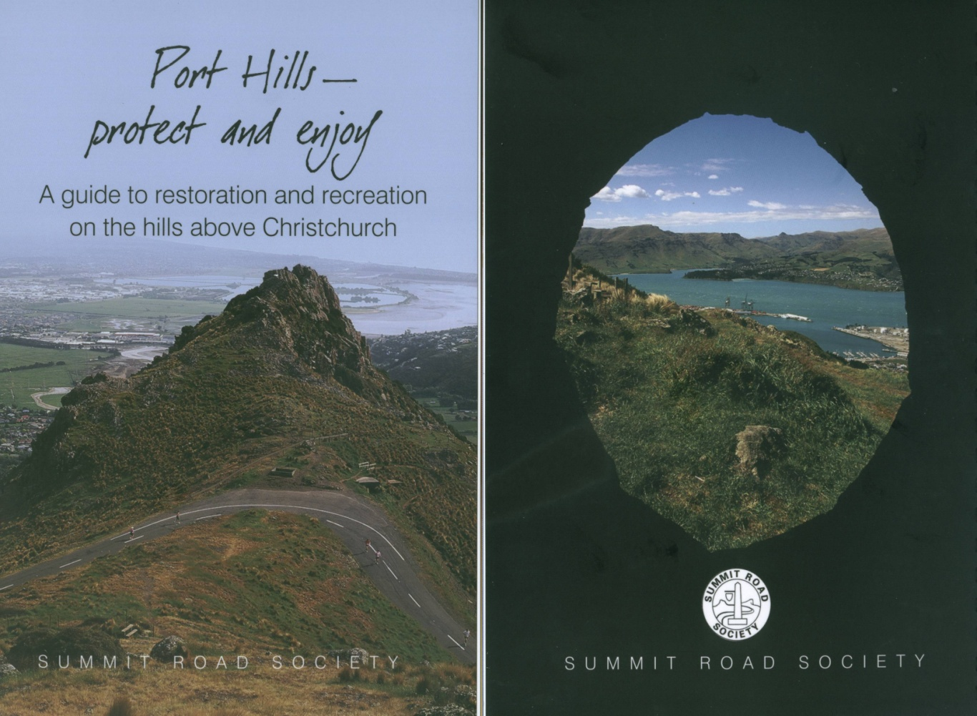
New publication from the Summit Road Society!!
With assistance from the NZ Lottery Grants Board, Holcim, Ground Effect and the Governors Bay Community Association, the Society is proud to make available this new publication, designed to fill a gap between brochures & maps and the more extensive books on the Port Hills.
The book is 48 pages in length and in full colour throughout. It serves as an introduction to the Port Hills, and has chapters on:
*The Port Hills walks *The Godley Head coastal defences
*Orienteering *Road and mountain biking
*The reserves *The volcanic landscape
*Harry Ell *Signs of the Kiwi and Takahe
*Bird spotting *Restoration
*Access *The Society itself
You need a copy of this book yourself, and it makes a great gift at only $20. Order your copies from the Secretary at P O Box 17-719, Christchurch
Please order promptly to help the Society recover its outlay.

Please send me ___ copies of the Port Hills book at $20 each, post free

Name ______________________________

Address ______________________________
______________________________
______________________________

I enclose my cheque for $20 for one book or ____ for ____ books

